Craig Pulford

Professor Jeffrey Seaman

Module 4 Assignment Proof

Chapter 35

Chapter 36

Chapter 37

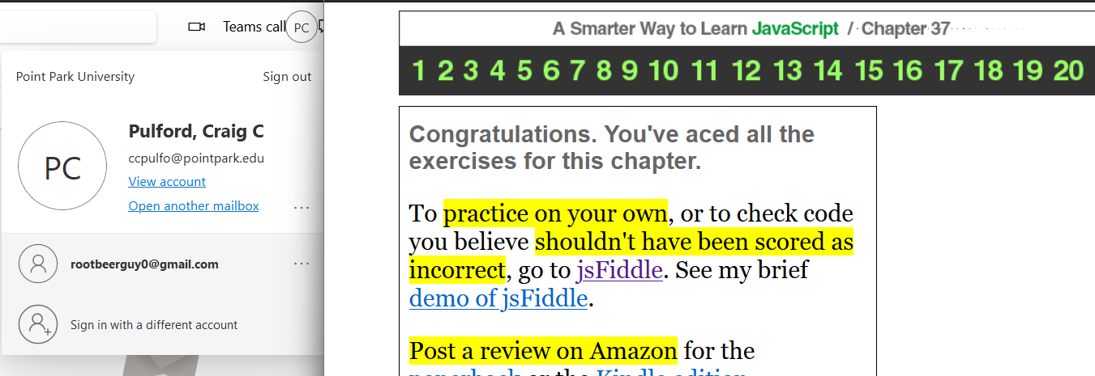

Chapter 38

Chapter 39 (look at link pls)

Chapter 40

Chapter 41 (pls look at link again pls)

Chapter 42

